LAB PROGRAMS
CSA1015-SOFTWARE ENGINEERING
1.Create a Kanban Board to Visualize the Tasks.
- Create Columns for To Do, In-Progress and Done.
- Add Atleast 5 Sample Tasks
- Move the Tasks across the Columns to Simulate the Workflow.

Create a kanban board and assign tasks
Step 1: Log in to jira account and create a new space from left side panel and select kanban template
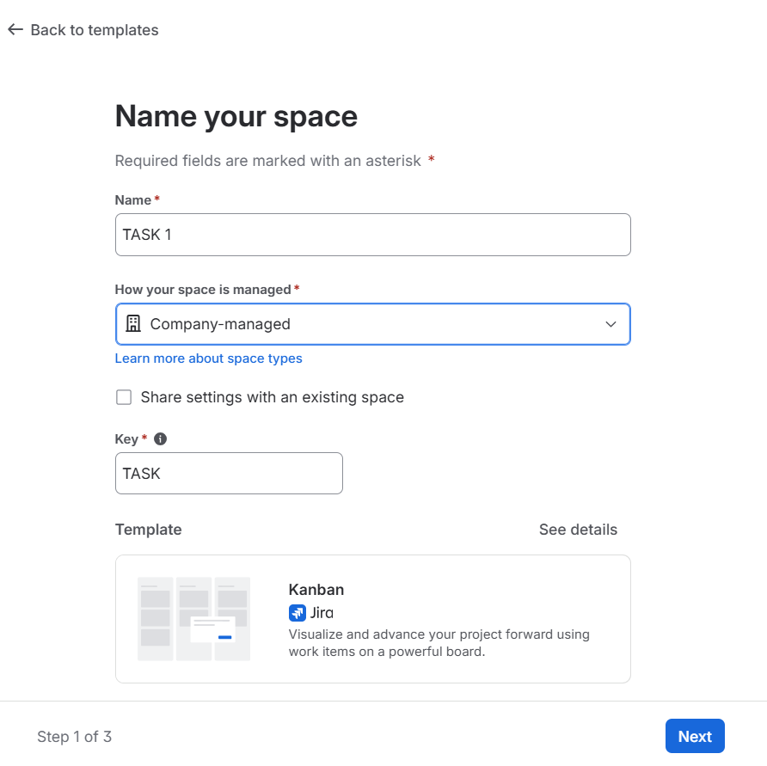
Step 2: Give the name of project

Step 3: Create the task in list and assign to team and date of task and priority level
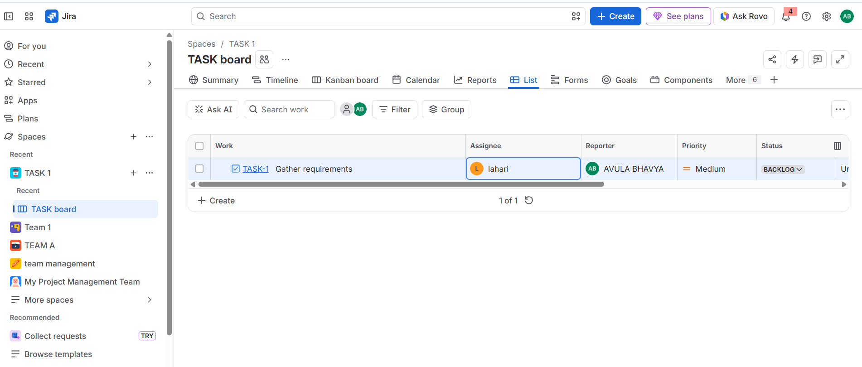
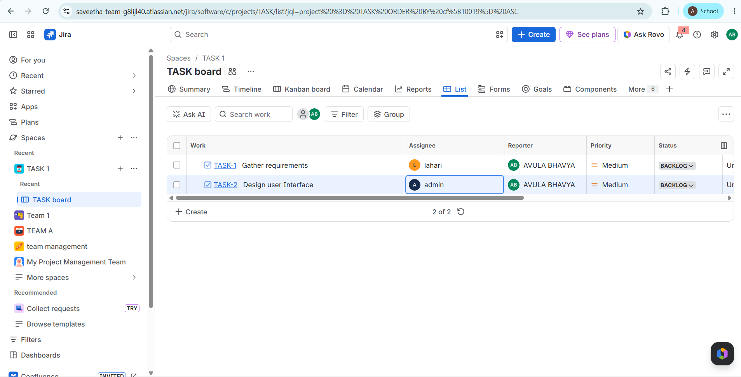

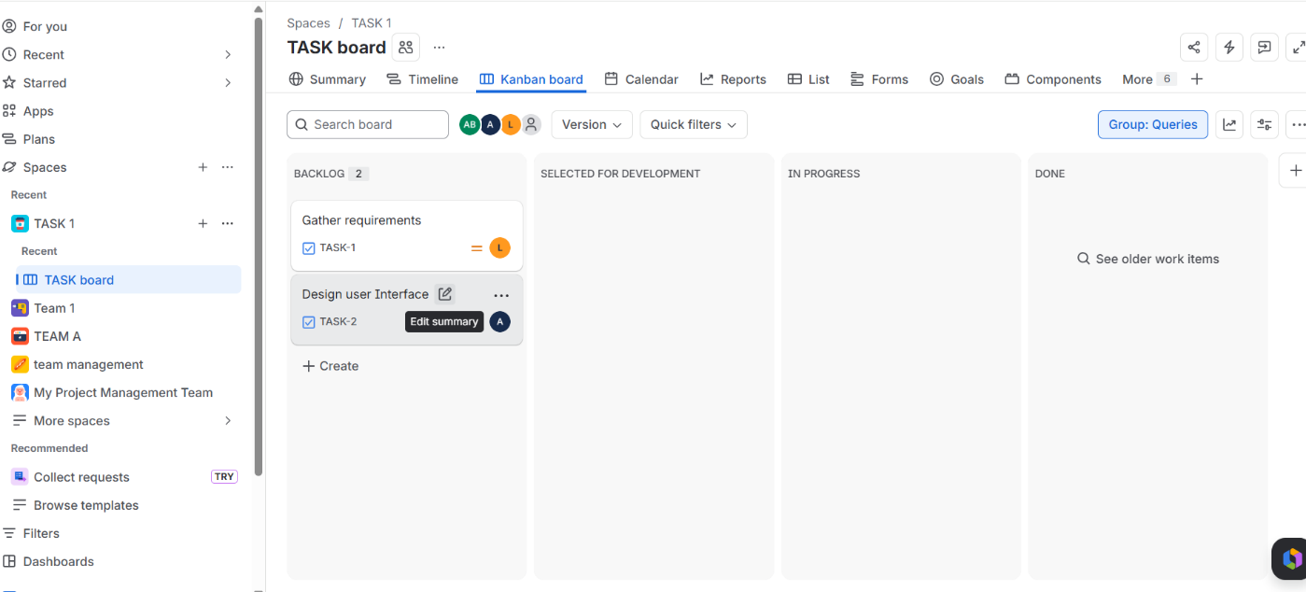
Step 4:Verify whether it is in kanban board

Step 5:Add all the task to list
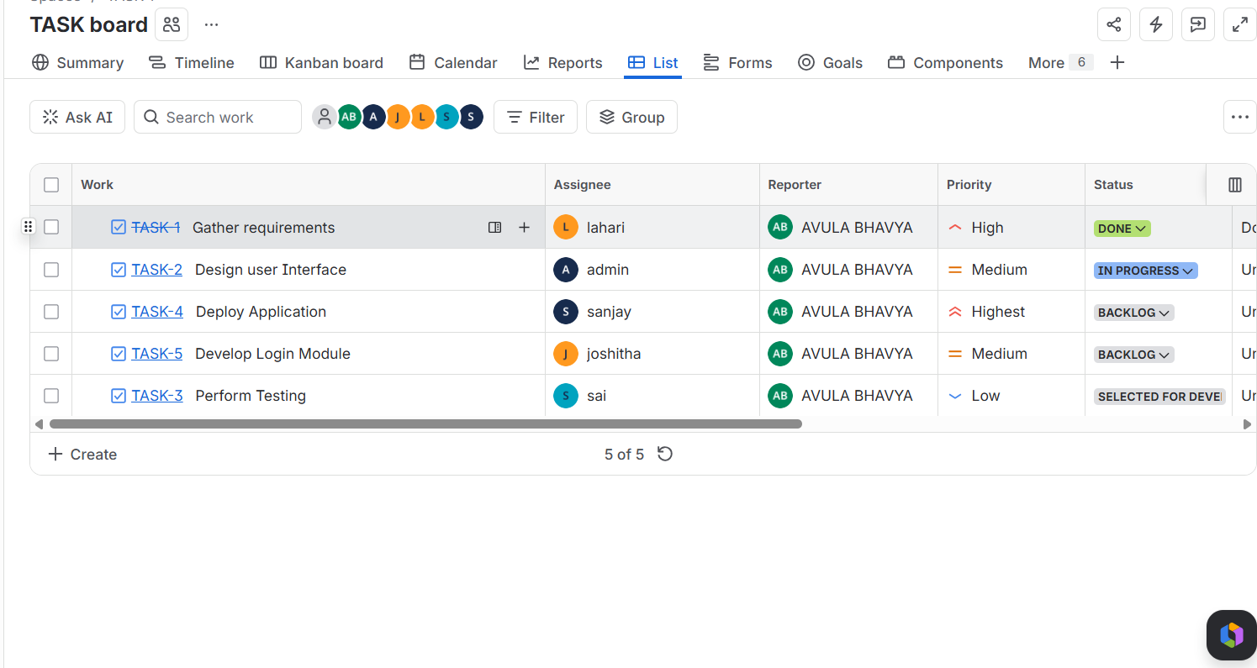
Step 6:We can verify all task in kanban board
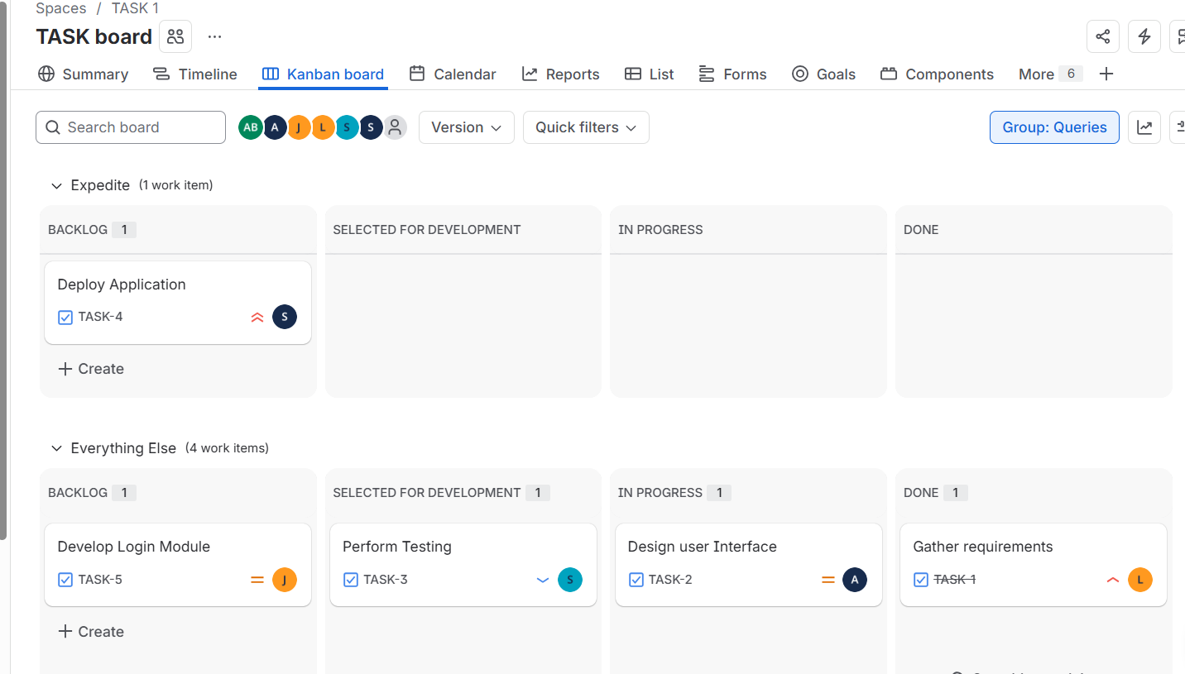

Step 7: We can see the summary in summary opt
